Declan Rodgers (B00371286)

COMP09086 2021

Chinook album management System



User Instruction Guide

Contents

1. Index Page and Navigation Bar 2

2. Artist Management 3

2.1 Artist View 3

2.2 Adding an Artist 3

2.3 Editing an Artist 5

3. Album Management 6

3.1 Album View 6

3.2 Adding an Album 7

3.3 Editing an Album 7

3.4 Deleting an Album 8

4. Album Detail /Track Management 8

4.1 Album Detail View 8

4.2 Adding a Track 10

4.3 Editing a Track 10

# Index Page and Navigation Bar

After deploying/running the MVC application and navigating to the address within your browser, you will be greeted with the homepage (pictured below with testing https://*localhost:5001* address).

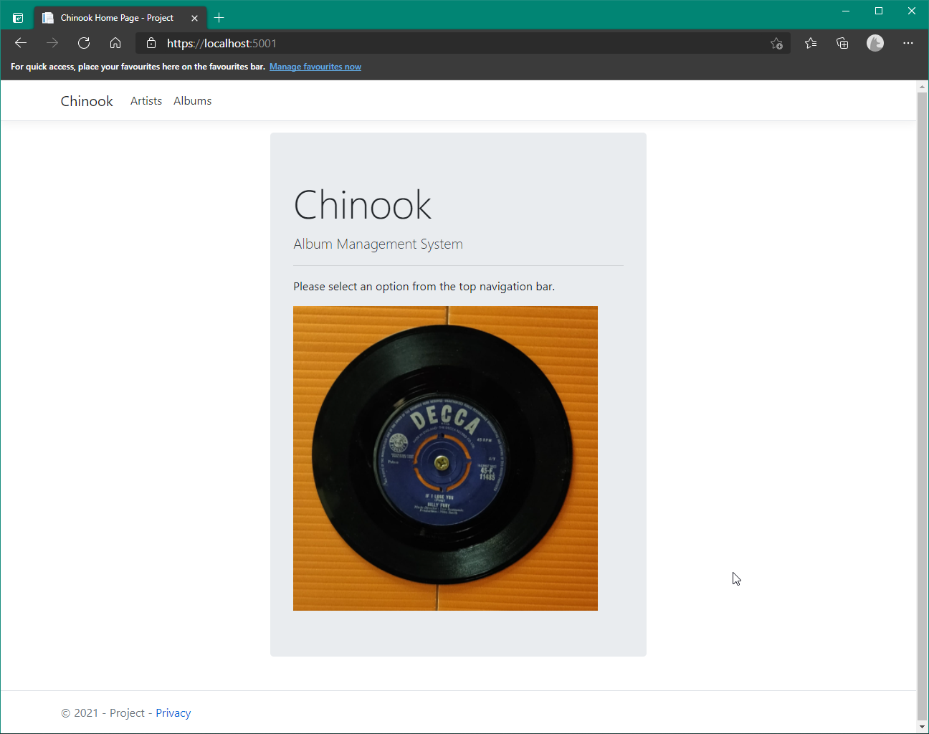

The Navigation Bar at the Top Right of the webpage allows you can click on 3 navigational links to easily manuever around the Web Application from section to section.



**Chinook** – Will take you back to the home page

**Artists** – To the Artist Section to Add or Edit Artists

**Albums** – To the Albums Section to Add, Edit or Remove Albums or view Album Details (Track Listing)

# Artist Management

## Artist View

The Artist View is the list of all the artists currently held in the system and displays them in Alphabetical Order. Action Buttons are to the Left of the Artist Table Heading and Artist Records

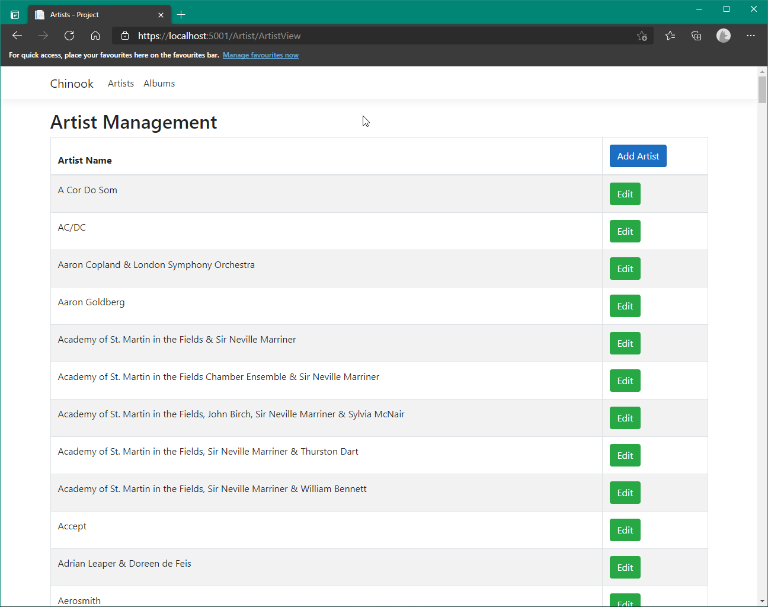

## Adding an Artist

Click the blue *‘Add Artist’* button labelled at the table heading for all the artists

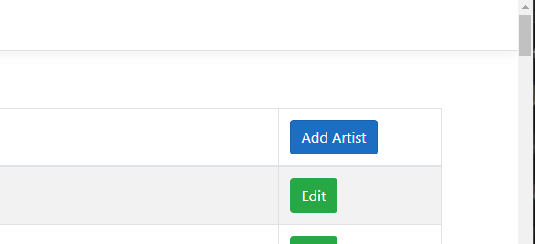

This will take you to the following Form page:

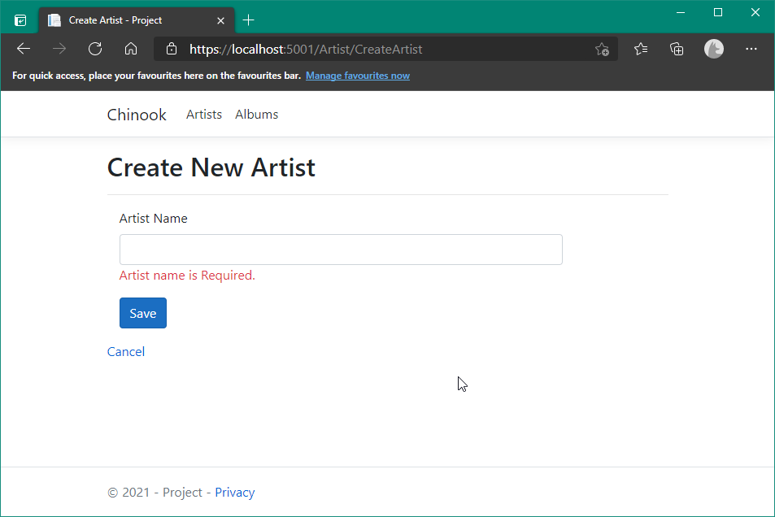

You will be presented a text box to put in the name of the New Artist. Click the *‘Save’* button to create the record.

**Note:** You will be unable to accidently save a record if you don’t put the required information in the sections provided or select an option from a Drop-Down menu. This restriction holds with any Section where you can Add/ Edit a record.

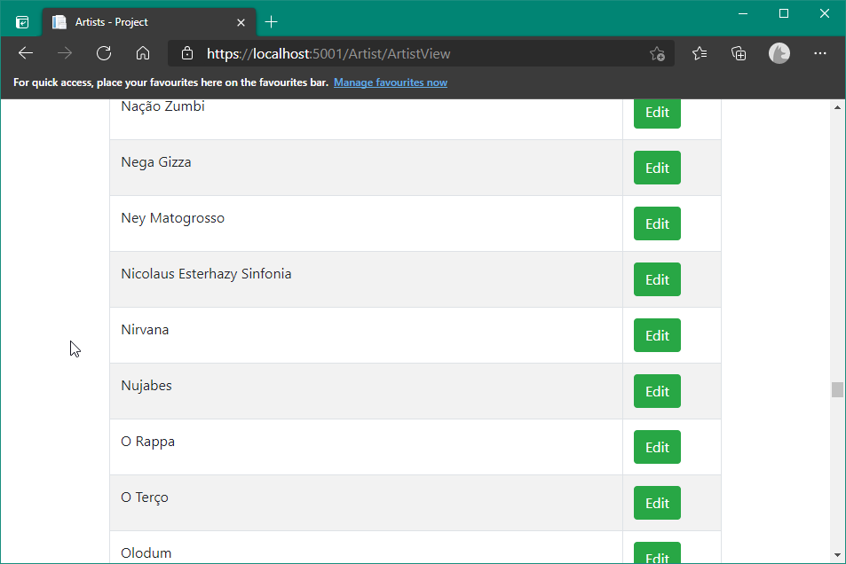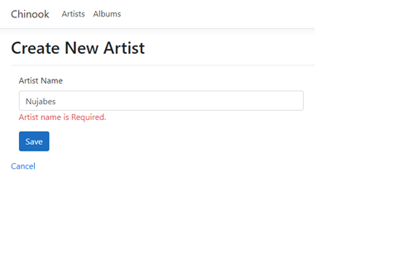

## Editing an Artist

Editing an Artist Record is done by selecting thew green *‘Edit’* button to the left in the Artist View table.

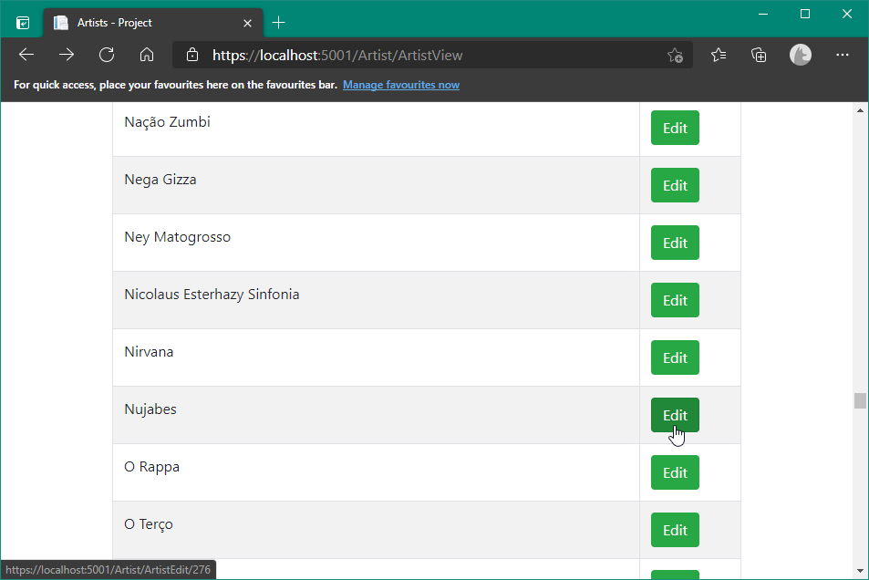

You can then apply any changes and select the *‘Update’* button to apply them.

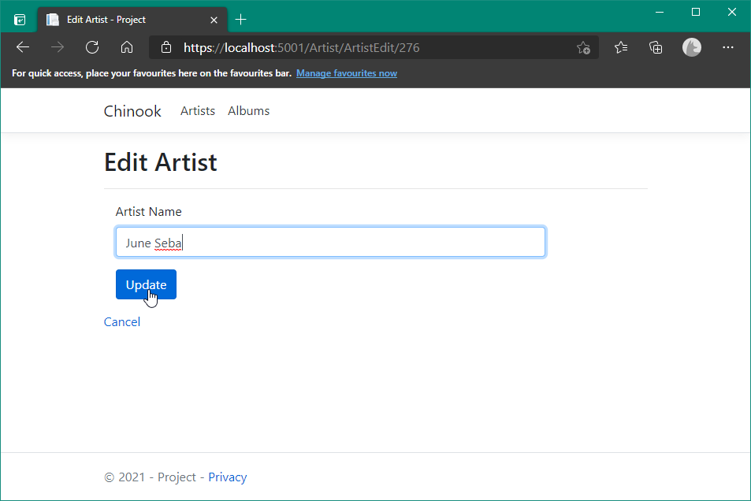

# Album Management

## Album View

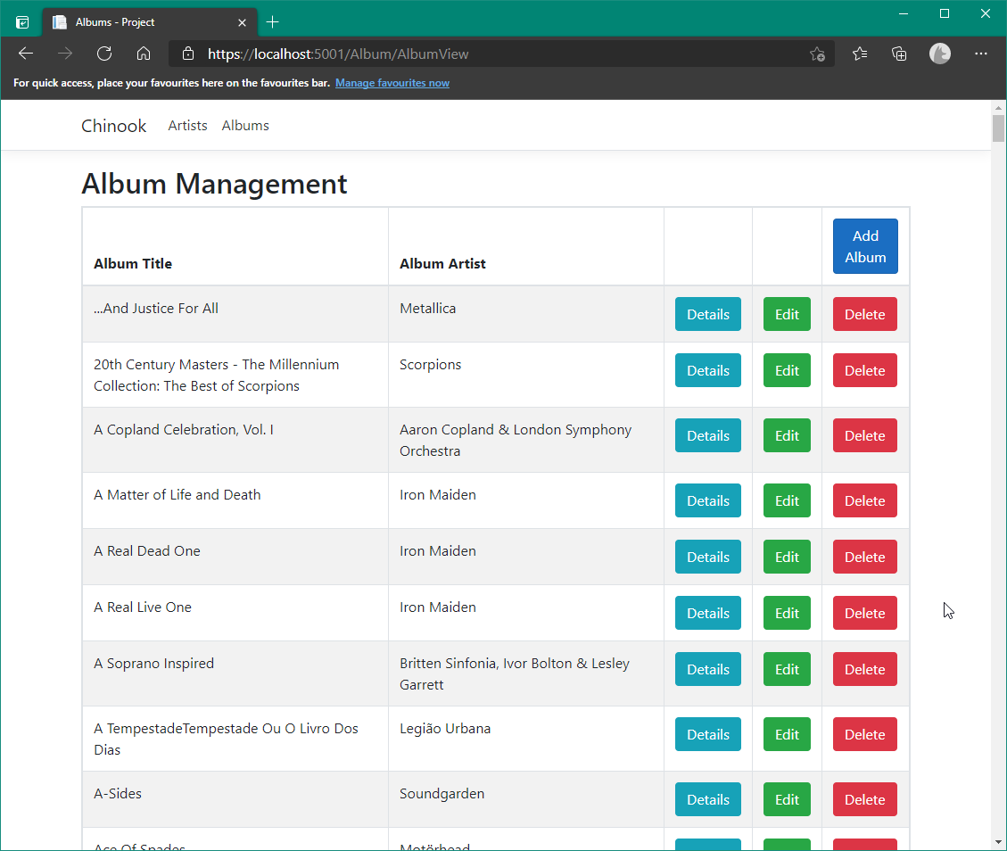

Similar to the Artist View, Albums are displayed in Alphabetical order.

*‘Add Album’* Button in the Table Header to add a new Album

*‘Details’* Button will show the Track listing for that Album and allow you to add/Edit Tracks.

*‘Edit’* Button will allow you do edit the Album Title and Artist

*‘Delete’* Button will remove the album

## Adding an Album

Like Adding an Artist, Click the ‘Add Album’ button which will bring you to a Form, then enter the Album Title and Select an Artist from the Drop-Down menu.

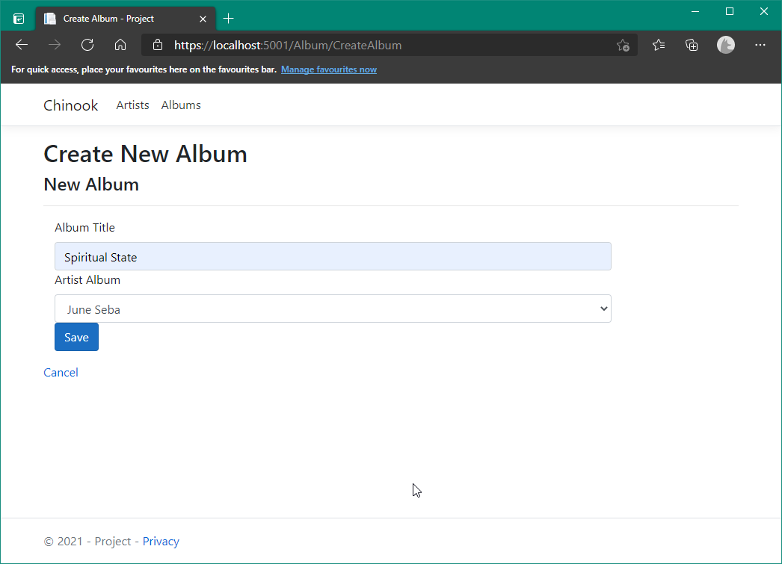

## Editing an Album

Clicking the *‘Edit’* button to the Right of the record will allow you change Album Title and/or Artist.

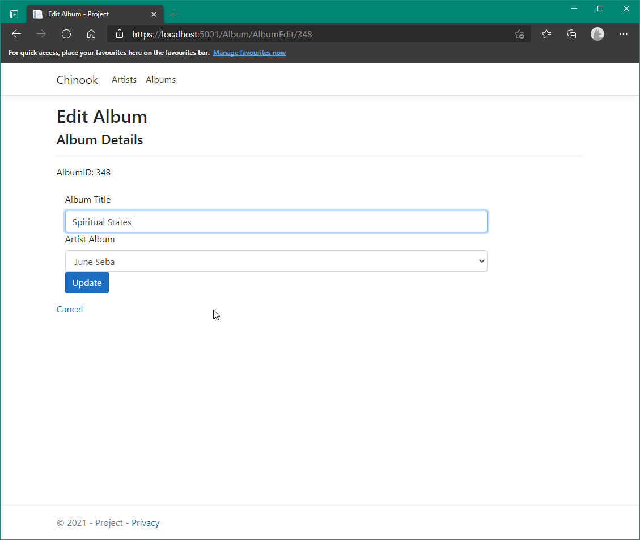

## Deleting an Album

Clicking the *‘Delete’* button on the far right of a record will bring up a Confirmation Box to make sure the removal of the Album Record was not accidental.

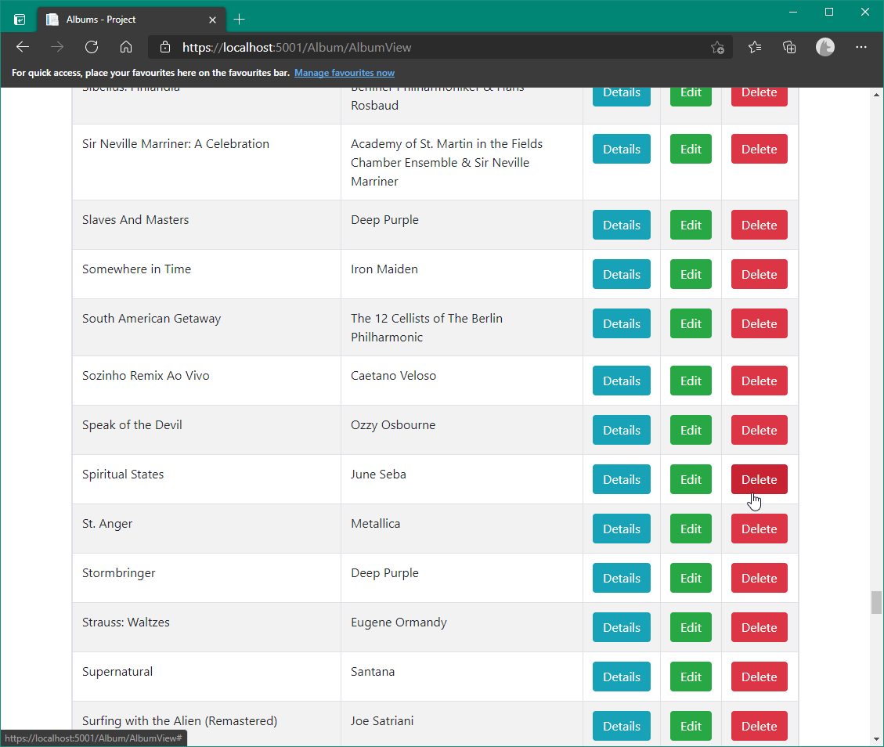

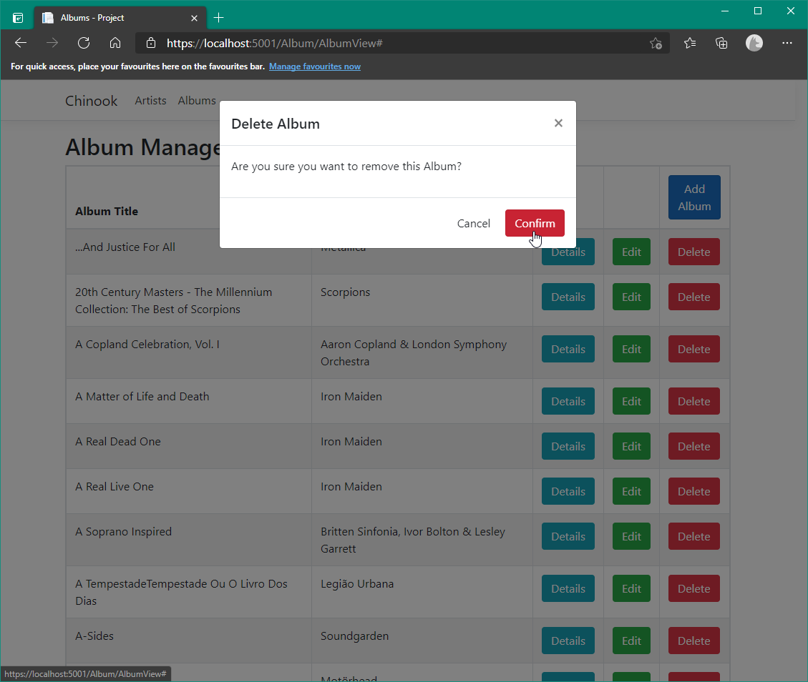

The page will then refresh, showing that the selected Album has been removed from the system.

**Note:** This will remove the Album *and* the associated Track records in the database.

# Album Detail /Track Management

## Album Detail View

Clicking the ‘Details’ Button takes you to the Details of an Album.

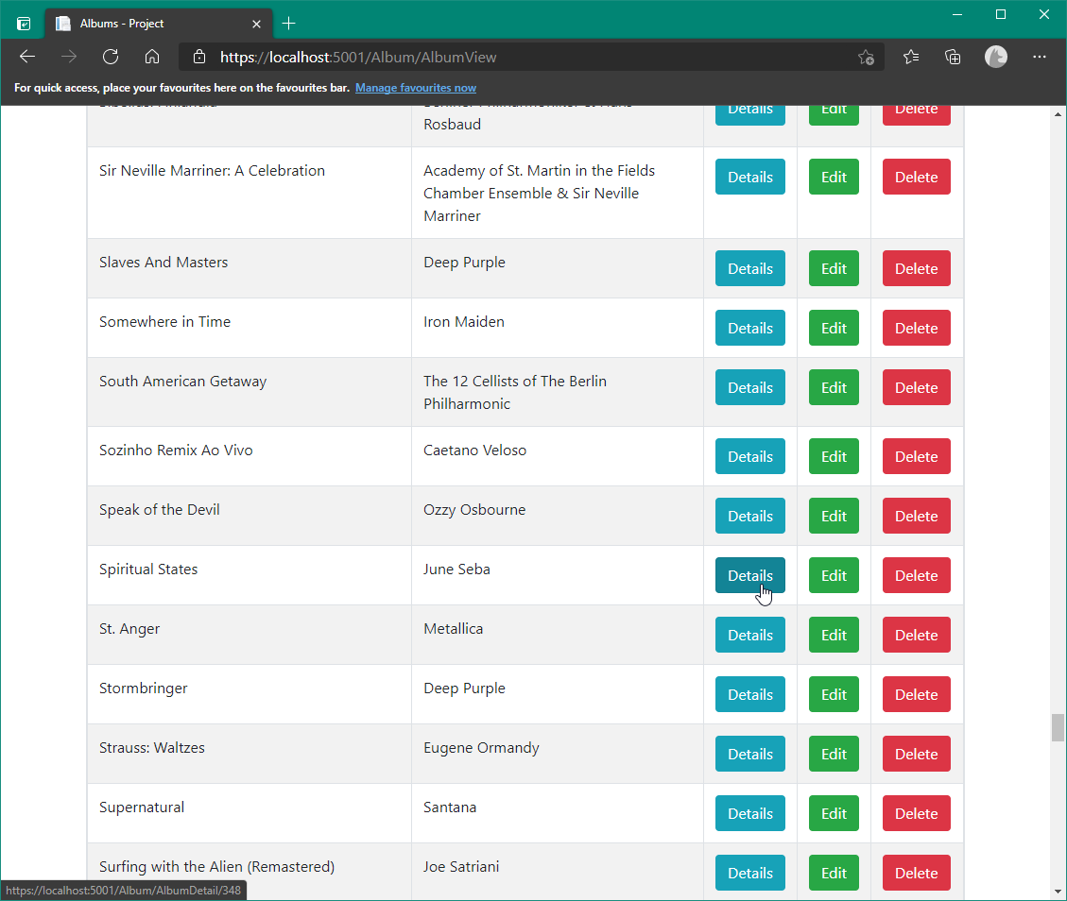

This will navigate you to another table with all the tracks for that Album.

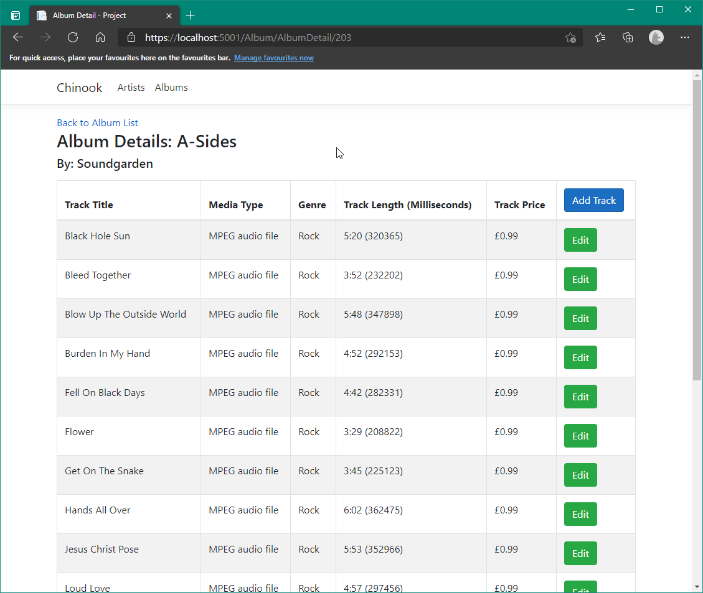

‘Add Track’ Button in the Table header will add another track for that specific album

‘Edit’ allows you to change Track details

If it is a new Album, no table is presented, only options to return to the Album View and a Button to ‘Add Track’

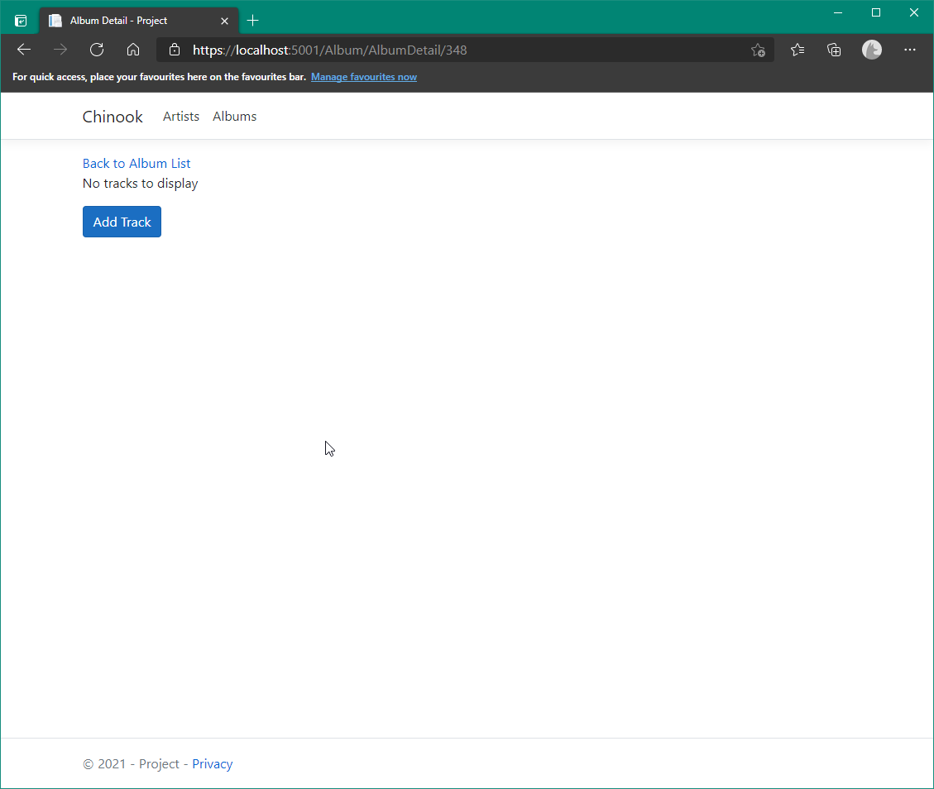

## Adding a Track

‘Add Track’ takes you to another Form page with sections to fill in to make new Track Record.

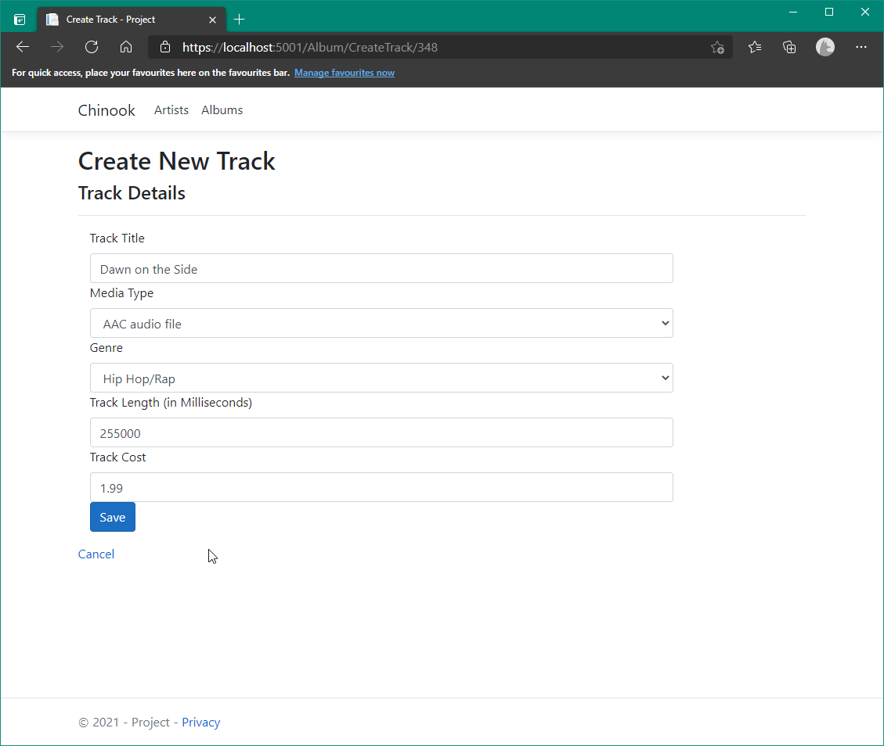

## Editing a Track

The Edit Button on the Album Detail View will allow you change the details for a track.

The only change from ‘Add Track’ is the TrackID and AlbumID are shown for the record in the database (for testing/debugging).

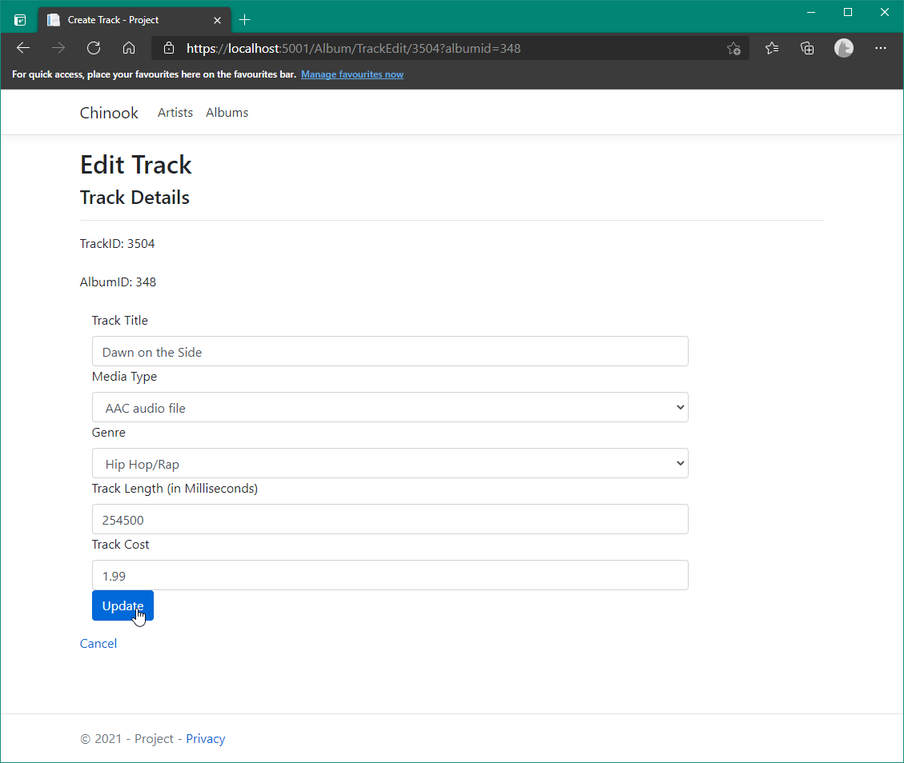

You will return to the Album’s Detail view, where you should see the Track changes applied.

